**University of the Punjab**

**Gujranwala Campus**

**Department of Information Technology**



**Assignment: Computer Vision**

**Prepared by:**

**Ayesha Khalid**

**Roll no:**

**BIT21011**

**Submitted to:**

**Miss Fouqia Zafeer**

**Image segementation task**

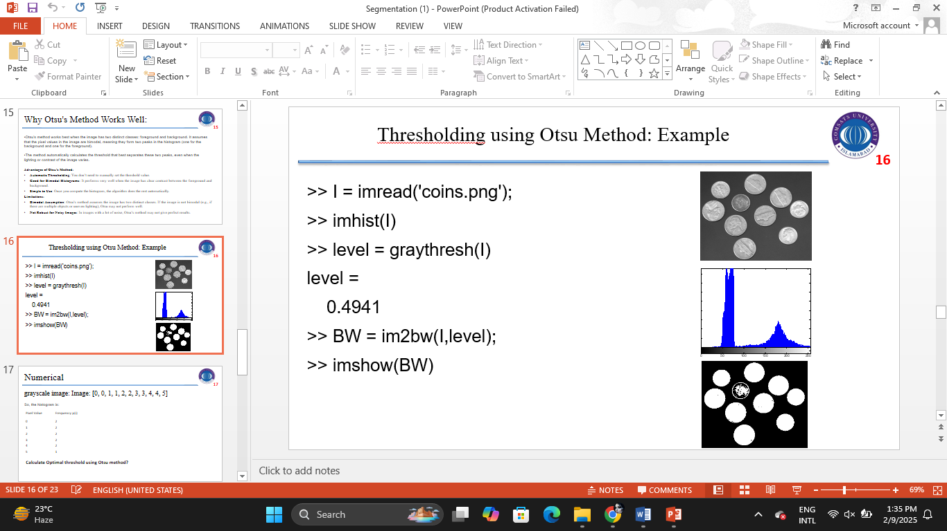

**MatLab ScreenShots**

I = imread('coins.png');

imhist(I)

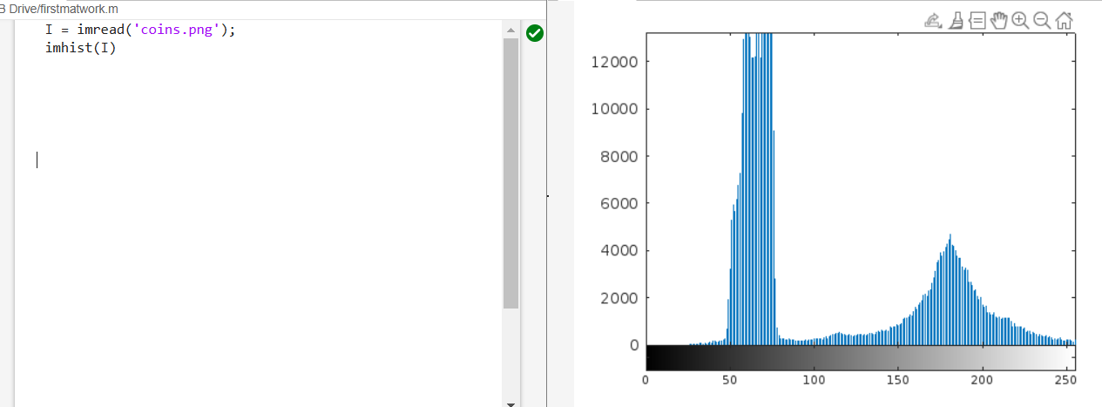

I = imread('coins.png');

BW = im2bw(I,level);

imshow(BW)

